**Magento: Positives**

*Order System*

* Cleaner and more organized layout than the old back-end
* Able to search orders by purchase order number, shipping or billing names and grand total
* “Search Inventory” function is straightforward to use and all the required information is clearly listed
* Custom Order Log is ready to read and understand where the item is along the pipeline

*Invoice System*

* Able to partially pay invoices without changing them from pending to complete

**Magento: Improvements**

*Order System*

* Being able to place orders without creating a quote first
  + Reverting back to the use of the “create new order” function

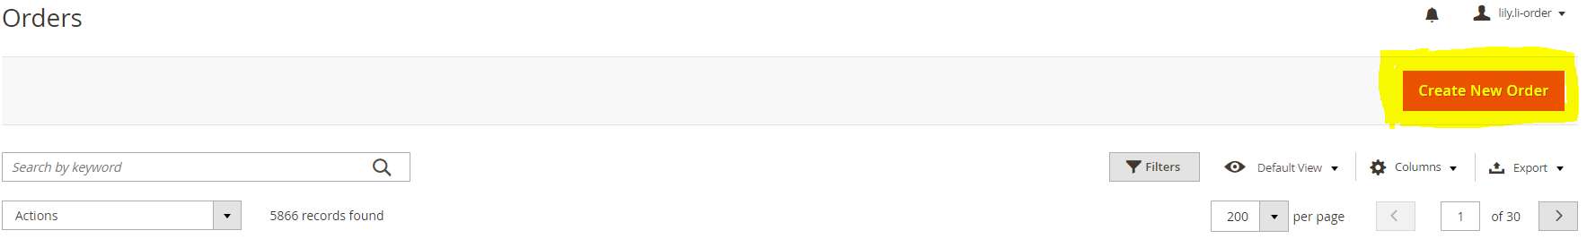

* Ability to cancel orders without having to use abmBOSS to delete the invoice first
* Adding a “Quotes” option under “Columns” as an additional means to filter orders

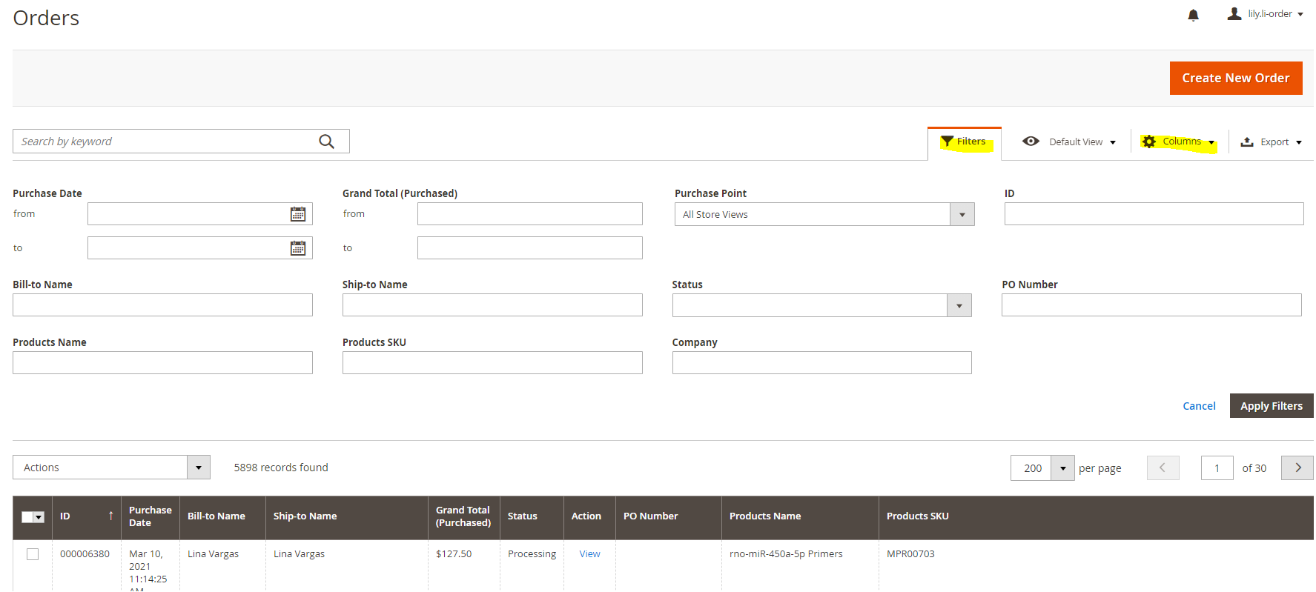

* Some customers have been complaining that when they place orders, they get to the shipping and handling portion and there is no selection. Therefore, they are unable to finish processing their orders.
  + It seems that the option: “to be determined – representative will adjust during order confirmation” doesn’t always work for customers
  + Had this issue pop up for both Canadian and US customers
  + Previous email examples were sent to IT and Ryan
* When opening any order, an “Attention” alert box always appears (see picture). If possible, please look into fixing this. It doesn’t heavily affect the operations but is extremely annoying to deal with when in a rush (ie. when placing orders on the phone, going between the invoice and order screen, etc.)

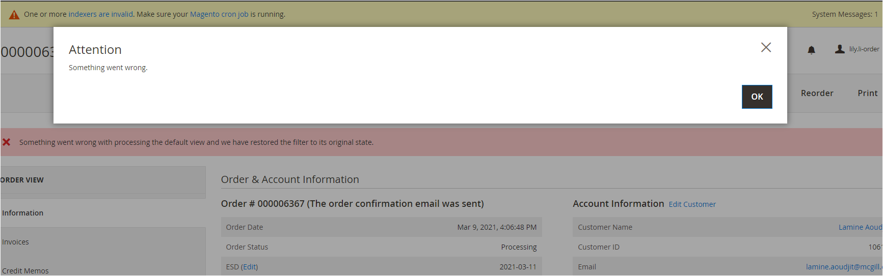

* Removal of the USD amount (highlighted in the picture) that appears above the CAD amount on CAD orders; the USD equivalent values doesn’t add value but can actually cause further confusion

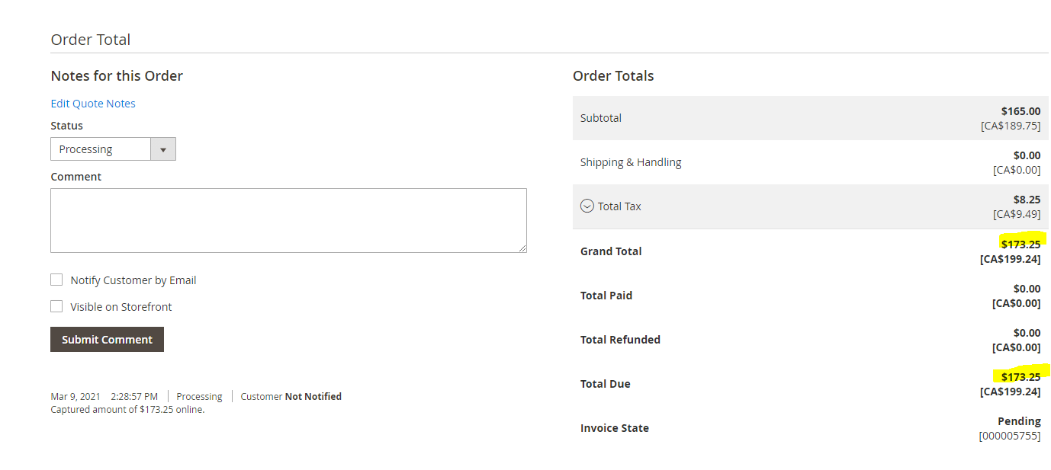

* Ability to enter the full SKU of items like viruses and vectors, instead of just the first 7 digits and then a series of selections, when generating orders, quotes or looking up items in the “search inventory” function

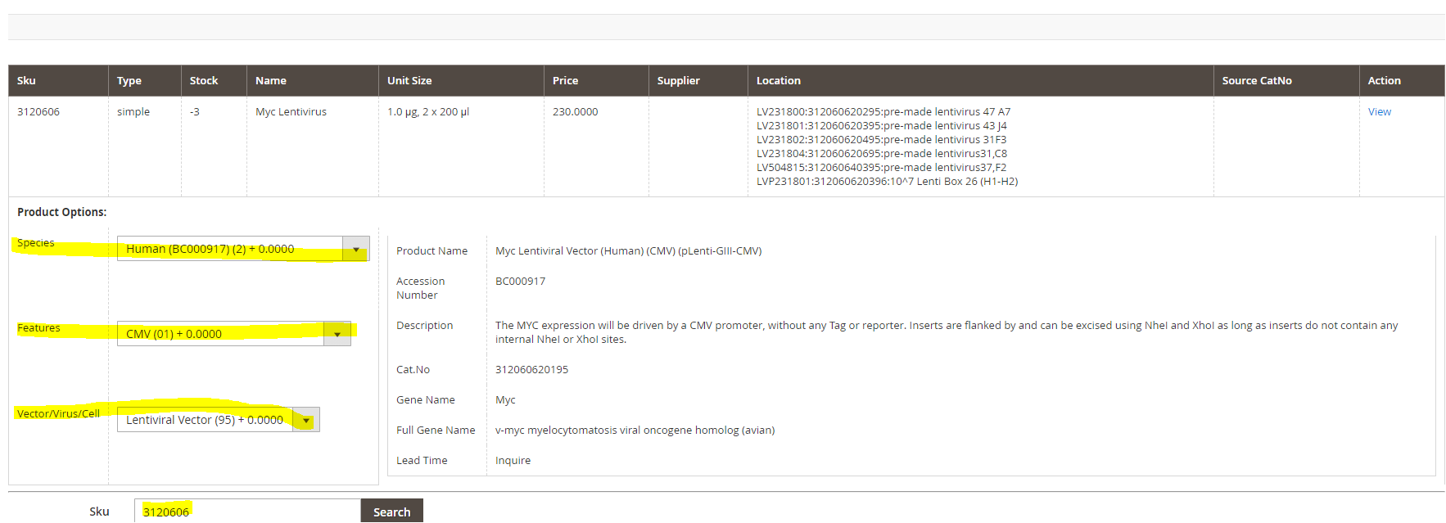

*Invoice System*

* If orders/invoices are $0 (ex. replacement or sample orders), then the invoice automatically marks itself as paid
* Having the billing address appear on the left side on invoices (like the old back-end, see photo below). This is to help with the mailing of physical invoices as only the shipping address can be seen through the envelope window.

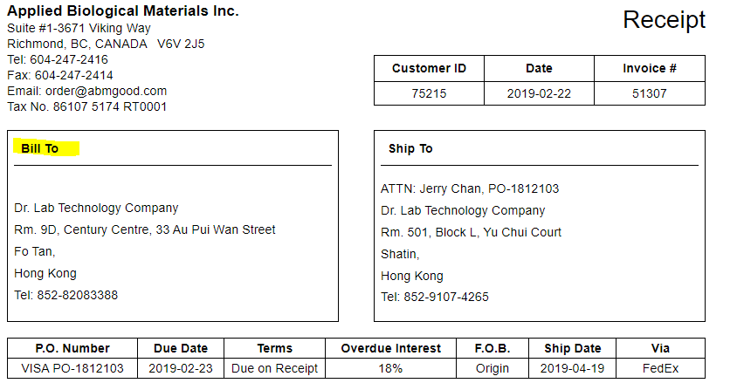

* Ability to edit certain aspects of the invoice
  + Payment terms (due on receipt, prepayment, Net 30); similar to the old back end (photo below)
  + Heading (Invoice, Proforma Invoice)
  + Invoice date

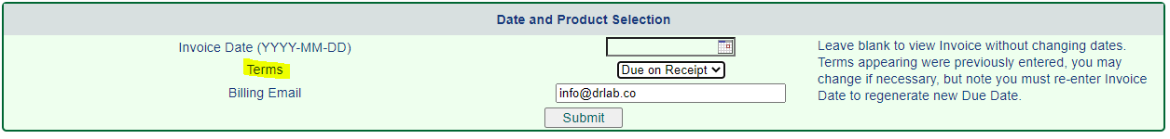

* This is currently fixed but it is crucial that the calculated tax on Canadian orders is correct. Otherwise, it will cause issues on the accounting side with the government – Needs to work more reliably
* Magento will automatically split invoices itself
  + Items will appear on both invoices (see example below where G478-Discountinued appears twice when order 4529 shows that only a quantity of 1 was ordered)
  + Shipping is also split evenly between the invoices – if possible, please change this so that it is invoiced only on one invoice
  + When there is a price or shipping fee increase, paid invoices should automatically revert to a pending state (currently, order team uses abmBOSS to un-pay the invoice) – see highlights in second image

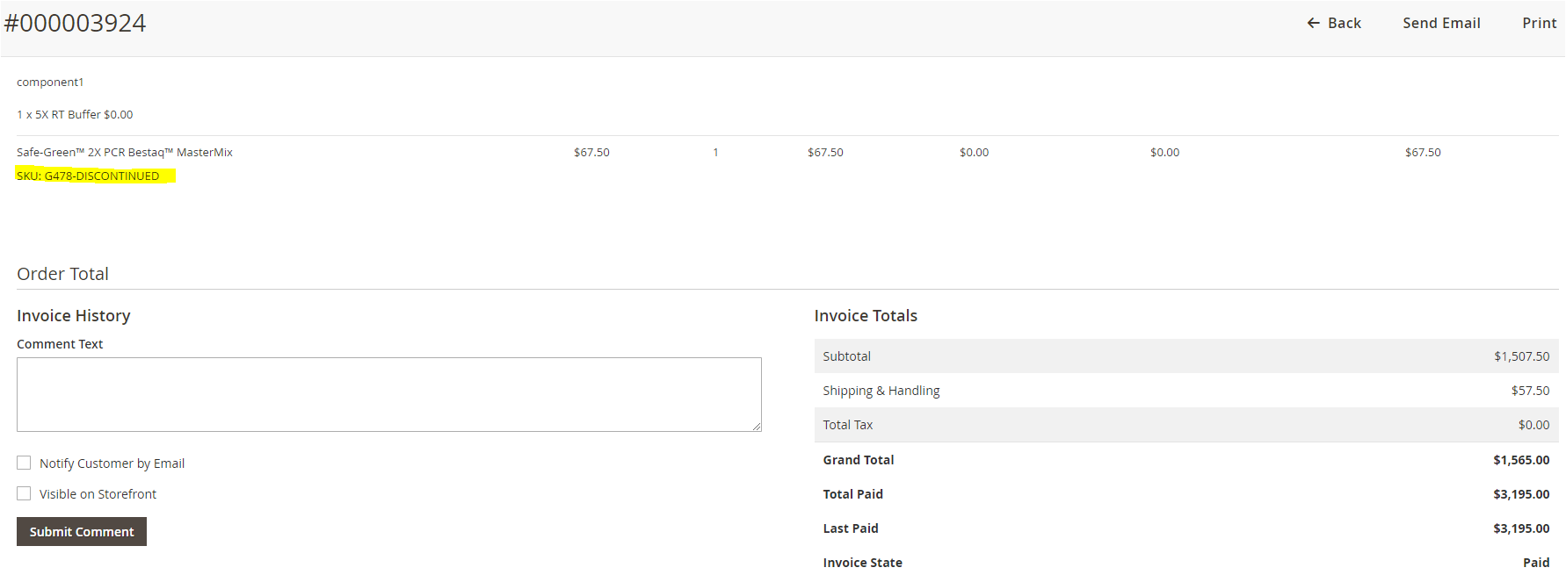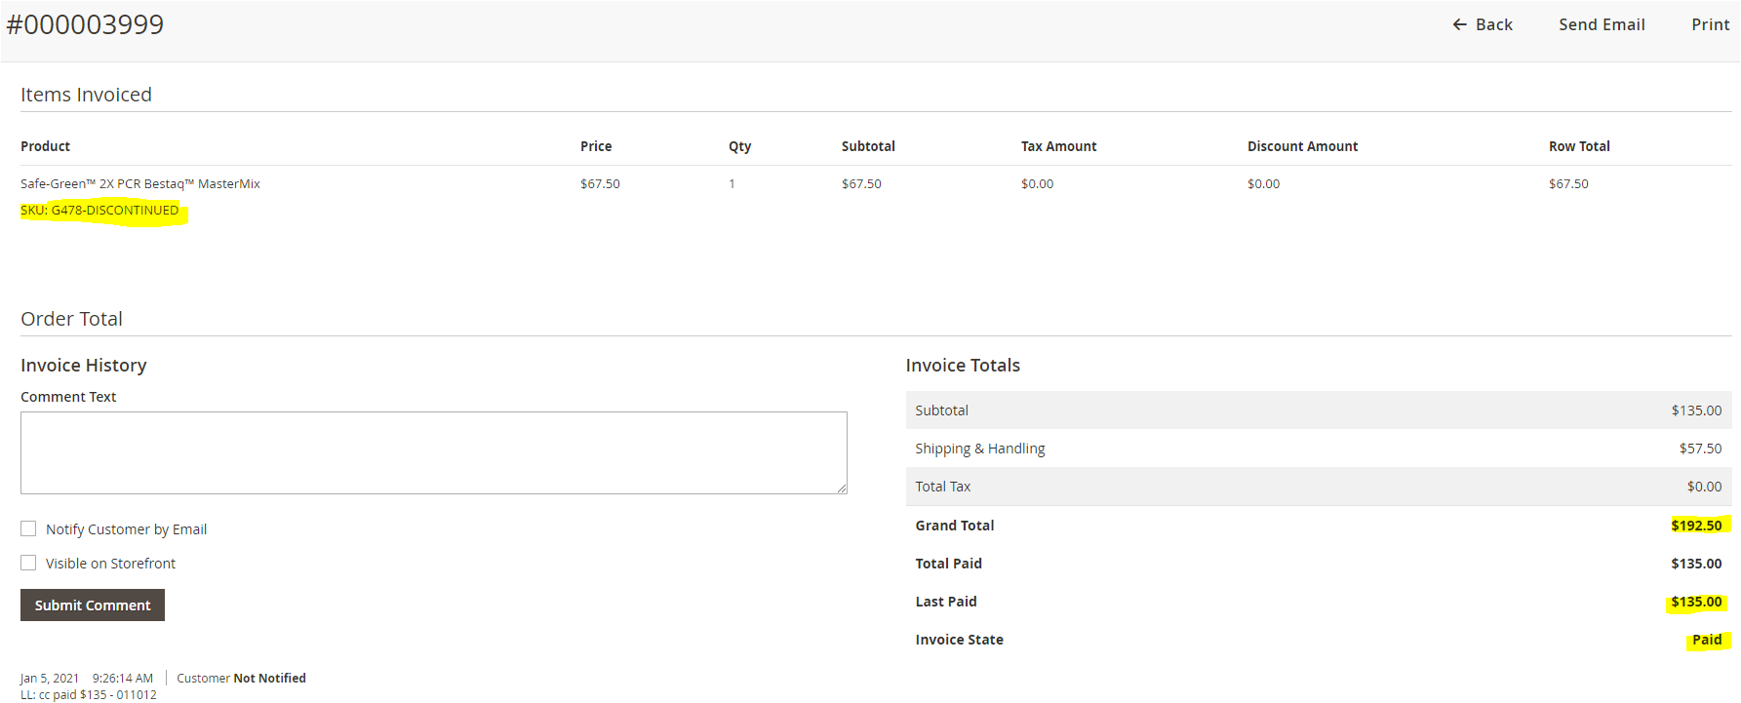

* When generating an invoice, sometime it drops the item price which causes the invoice to become $0. As of now, order team uses the abmBOSS program to delete multiple invoices until item list price fixes itself
  + Many email examples were provide to IT and Ryan in the past

**Magento: New Functions**

* Instead of showing base amount on the preview screen, have it show the amount paid or amount due
  + The Grand Total (Base) doesn’t really add value. If it could show how much is outstanding, this would be helpful in the generation of account statements

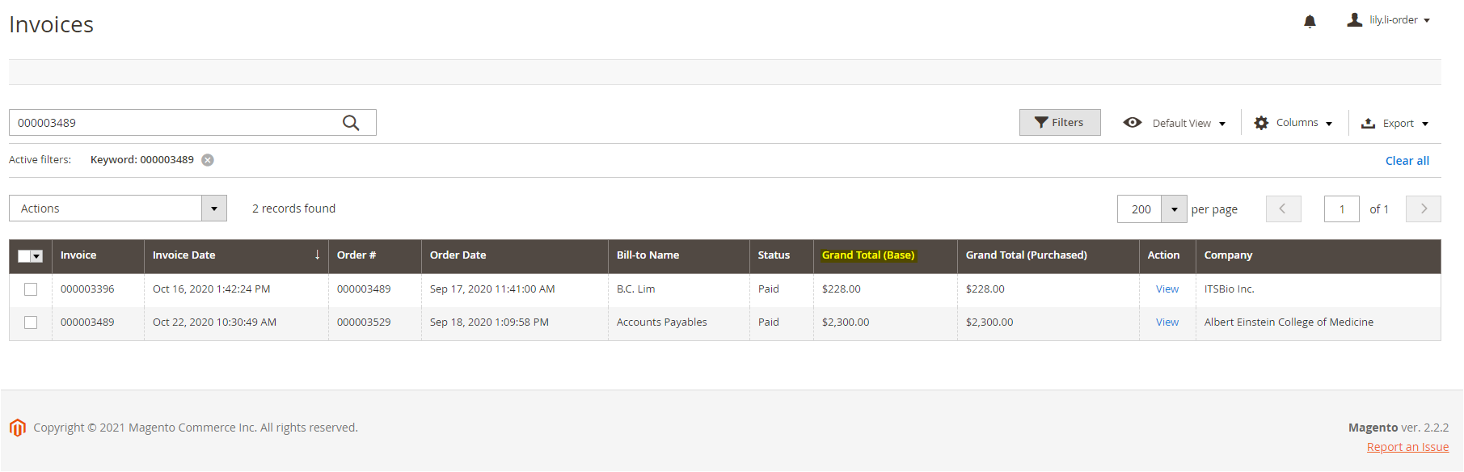

* Ability to create credit memos directly from Magento (there seems to be a section for this already but no function to create the actual document)

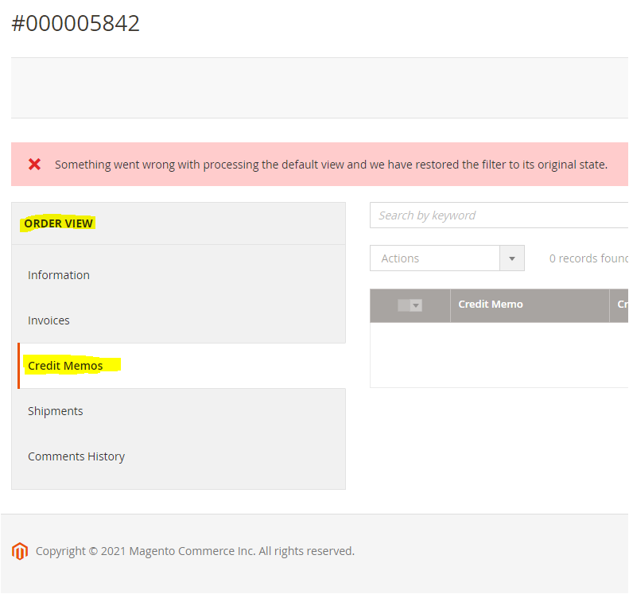

* Making it possible for the invoice be sent as a PDF attachment instead of being a body of text when using Magento’s “send email” function on the invoice screen
  + Many accounts payable email systems cannot accept the invoice as text and require it to be an attachment

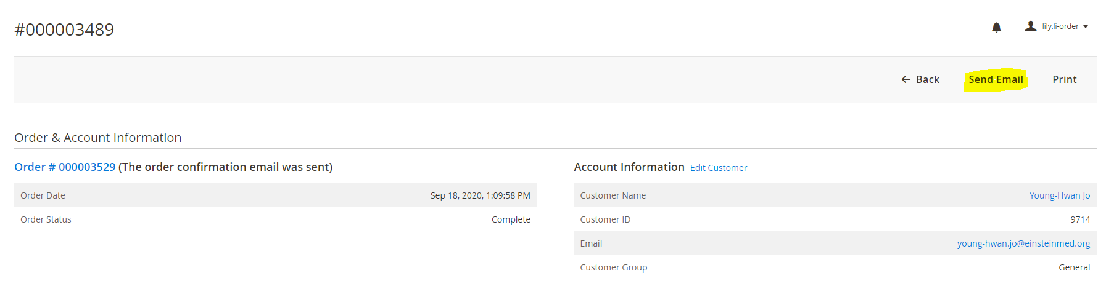

* Ability to increase or decrease item quantities once the order has been processed
  + Currently, we are only able to delete the whole item regardless of how many quantities were ordered

• Currency (USD/CAD/CNY) adjusted automatically depending on the inputted address

* + The default currency for the next order or quote generated is the last used currency. This can cause a currency mix ups if order team or technical is not careful. Therefore, to decrease the number of these cases, it would be appreciated if Magento could choose the correct currency for us. However, it should still be possible to adjust this ourselves for specific customers (ex. Signalchem is a Canadian company but orders are processed as USD)
  + CNY (which is 1.5x the USD pricing) should be chosen by Magento for international addresses
  + The idea is to mirror what Magento already does when the customer places the online orders themselves
* Magento sends alerts to the designated order group (cell/lenti/cloning/buy) if the order is passed its ESD but the “update log” isn’t marked complete
  + This will help remind the designated department that they are running behind schedule and will remind order team to send an update email to the customer (we can take more initiative rather than have the customer always follow up with us)
* When customers place orders online and the item they are requesting is out of stock, it would be good if Magento could show a pop-up message informing them it is out of stock. Although the actual lead time still needs to be filled in by order team, this will give the customer a heads up that their order isn’t going to be ready immediately.
* Similar to how customers can set default shipping and billing addresses, it would be good if customers who pay with credit card could save a default payment method. This would help save time and prevent errors in re-typing the cc information every time
  + Idea is similar to how Magento can grab FedEx account numbers
  + Helpful with distributors/OEM partners who order from us often (currently, the cc information is just stored in the account notes. This can cause clutter overtime or be easily overlooked among the other information)

